45 DAYS INDUSTRIAL TRAINING REPORT
ON
ENTERPRISE CREDIT CARD FRAUD INTELLIGENCE
COMPLETED AT
WHITE HAT CODERS, MOHALI

By
Harsimrat Kaur
(23303120)



DEPARTMENT OF COMPUTER SCIENCE AND ENGINEERING
SARDAR BEANT SINGH STATE UNIVERSITY, GURDASPUR
June, 2026
ABSTRACT

The rapid growth of digital payment systems, online banking services, and electronic commerce has significantly transformed the financial sector by providing faster, more convenient, and secure methods of conducting financial transactions. However, this digital transformation has also resulted in a substantial increase in financial fraud, particularly credit card fraud, identity theft, unauthorized transactions, and other cyber-enabled financial crimes. Financial institutions process millions of transactions every day, making it increasingly difficult to identify fraudulent activities using traditional monitoring techniques. Conventional fraud detection systems often depend on manual investigation or rule-based mechanisms that are time-consuming, less scalable, and incapable of identifying complex fraud patterns hidden within large volumes of transaction data. Consequently, there is a growing demand for intelligent analytical systems capable of processing large datasets, detecting suspicious activities, and generating actionable business insights that support faster and more informed decision-making.
The Enterprise Credit Card Fraud Intelligence & Risk Analytics project has been developed to address these challenges by utilizing modern Business Intelligence and Data Analytics techniques. The primary objective of this project is to design and implement an interactive analytical dashboard that transforms large-scale financial transaction data into meaningful business intelligence using Microsoft Power BI. The project demonstrates how advanced data visualization, data modeling, and analytical reporting can assist financial organizations in identifying fraud trends, monitoring transaction performance, evaluating customer behavior, and supporting strategic business decisions.
The project utilizes the PaySim Financial Transaction Dataset, a widely recognized dataset that simulates real-world mobile money transactions. The dataset contains more than one million transaction records and includes several important attributes such as transaction type, transaction amount, customer identifiers, merchant identifiers, account balances before and after each transaction, fraud indicators, and system-generated fraud flags. The large volume of data makes it an ideal dataset for demonstrating large-scale data analytics techniques and Business Intelligence reporting. The dataset was imported into Microsoft Power BI, where extensive preprocessing and transformation activities were performed to improve data quality and prepare it for analysis.
A significant portion of the project focuses on data preparation, which is one of the most critical stages in any data analytics project. Before meaningful analysis can be performed, the raw transaction data must undergo several preprocessing operations including removing duplicate records, correcting inconsistent data formats, handling missing values, modifying column data types, removing unnecessary attributes, and creating additional calculated columns wherever required. These preprocessing activities were carried out using Power Query Editor, which provides a graphical interface for performing Extract, Transform, and Load (ETL) operations. Data cleaning not only improves analytical accuracy but also enhances dashboard performance by reducing unnecessary processing overhead.

ACKNOWLEDGEMENT

The successful completion of this project marks an important milestone in my academic journey and would not have been possible without the guidance, encouragement, and support of many individuals and organizations. I would like to express my sincere gratitude to everyone who directly and indirectly contributed towards the successful completion of my internship project titled "Enterprise Credit Card Fraud Intelligence & Risk Analytics Using Power BI." This project has not only enhanced my technical knowledge in the field of Data Analytics but has also provided me with practical exposure to solving real-world business problems using modern Business Intelligence tools.
First and foremost, I would like to express my heartfelt gratitude to White Hat Coders for providing me with the opportunity to undertake this internship and work on such an industry-relevant project. The internship offered an excellent platform to bridge the gap between theoretical knowledge gained during academic studies and its practical implementation in the field of Data Analytics. The professional environment, learning opportunities, and technical guidance provided throughout the internship have significantly contributed to my personal and professional growth.
I extend my sincere appreciation to my project mentor and all the technical professionals at White Hat Coders for their constant support, valuable suggestions, and constructive feedback throughout the development of this project. Their guidance helped me understand the practical aspects of Business Intelligence, data visualization, data modeling, and analytical reporting. Their willingness to share their knowledge and industry experience inspired me to approach every stage of the project with confidence and enthusiasm. Their continuous motivation encouraged me to overcome various technical challenges encountered during the implementation of the project.
I would also like to express my deepest gratitude to the faculty members of Sardar Beant Singh State University, Gurdaspur, for providing me with the academic foundation required to undertake this project successfully. The concepts learned during my coursework in Data Analytics, Database Management Systems, Business Intelligence, and Computer Science have played a vital role in understanding the technical aspects involved in developing this project. I am especially thankful to my project guide and departmental faculty members for their valuable guidance, timely suggestions, and constant encouragement throughout the internship period. Their support has motivated me to continuously improve my analytical and problem-solving abilities.

TABLE OF CONTENTS
CHAPTER NO. | TITLE | PAGE NO.
 | CERTIFICATE OF TRAINING
 | ABSTRACT | 2
 | ACKNOWLEDGEMENT | 3
 | LIST OF FIGURES | 6
 | LIST OF TABLES | 7
 | LIST OF ABBREVIATIONS | 8
1 | INTRODUCTION | 10
 | 1.1 Project Overview | 11
 | 1.2 Problem Statement | 12
 | 1.3 Objectives of the Project | 13
 | 1.4 Scope of the Project | 15
 | 1.5 Project Methodology | 16
 | 1.6 Tools and Technologies Used | 20
2 | LITERATURE SURVEY | 22
 | 2.1 Introduction to Credit Card Fraud | 23
 | 2.2 Existing Fraud Detection Techniques | 24
 | 2.3 Business Intelligence in Fraud Analytics | 25
3 | SYSTEM DEVELOPMENT | 26
 | 3.1 System Design | 27
 | 3.2 System Architecture | 28
 | 3.3 Dataset Description (PaySim) | 29
 | 3.4 Data Cleaning and Transformation | 30
 | 3.5 Data Modeling (Star Schema) | 31
 | 3.6 DAX Measures and KPIs | 32
 | 3.7 Dashboard Development | 33
4 | PERFORMANCE ANALYSIS | 34
 | 4.1 Executive Fraud Intelligence Dashboard Analysis | 35
 | 4.2 Transaction Analytics Dashboard Analysis | 36
 | 4.3 Fraud Behaviour Dashboard Analysis | 37
 | 4.4 Key Business Insights | 38
 | 4.5 Benefits of the Developed System | 39
5 | CONCLUSION AND FUTURE SCOPE | 40
 | 5.1 Conclusion | 40
 | 5.2 Future Scope | 41
 | REFERENCES | 42
 | APPENDICES | 43

LIST OF FIGURES

Figure No. | Figure Title
Figure 3.1 | Star Schema Data Model
Figure 3.2 | Executive Fraud Intelligence Dashboard
Figure 3.3 | Transaction Analytics Dashboard
Figure 3.4 | Fraud Behaviour Dashboard

LIST OF TABLES

TABLE NO. | TITLE OF TABLE
Table 1.1 | Objectives of the Project
Table 1.2 | Tools and Technologies Used
Table 2.1 | Summary of Literature Survey
Table 3.1 | PaySim Dataset Description
Table 3.2 | Data Dictionary of PaySim Dataset
Table 3.3 | Data Cleaning and Transformation Steps
Table 3.4 | Fact and Dimension Tables
Table 3.5 | DAX Measures and KPIs
Table 4.1 | Executive Dashboard KPIs
Table 4.2 | Fraud Analysis Summary
Table 4.3 | Business Insights and Recommendations
Table 5.1 | Project Outcomes

LIST OF ABBREVIATIONS

ABBREVIATION | FULL FORM
AI | Artificial Intelligence
BI | Business Intelligence
CSV | Comma Separated Values
DAX | Data Analysis Expressions
DBMS | Database Management System
ETL | Extract, Transform and Load
KPI | Key Performance Indicator
ML | Machine Learning
OLAP | Online Analytical Processing
PBI | Power BI
PDF | Portable Document Format
PQ | Power Query
RDBMS | Relational Database Management System
SQL | Structured Query Language
UI | User Interface
UX | User Experience
API | Application Programming Interface
CSV | Comma Separated Values
ID | Identification
IT | Information Technology
MIS | Management Information System
ODBC | Open Database Connectivity
SaaS | Software as a Service
GUI | Graphical User Interface
TNR | Times New Roman
PaySim | Payment Simulator Dataset
PBIX | Power BI Project File
Fact Table | Central table containing measurable transaction data
Dimension Table | Supporting table containing descriptive attributes

CHAPTER 1
INTRODUCTION

The rapid advancement of information technology has significantly transformed the way financial transactions are conducted across the world. The widespread adoption of online banking, mobile payment applications, digital wallets, and credit card services has made financial transactions faster, more convenient, and accessible to millions of users. Financial institutions process an enormous volume of transactions every day, ranging from small retail purchases to large business payments. While this digital transformation has improved customer convenience and operational efficiency, it has also created new opportunities for fraudulent activities. Cybercriminals continuously exploit vulnerabilities in digital payment systems to perform unauthorized transactions, identity theft, account takeovers, and various forms of financial fraud. As a result, detecting and preventing fraudulent transactions has become one of the most critical challenges for banks, financial organizations, and payment service providers.
Traditional fraud detection methods primarily rely on manual monitoring, predefined business rules, and periodic reporting. Although these methods have been used for many years, they are often insufficient for handling today's rapidly increasing transaction volumes. Manual analysis is time-consuming, expensive, and highly dependent on human expertise. Moreover, static reports are unable to provide real-time insights or identify hidden fraud patterns present within millions of transaction records. Financial institutions therefore require intelligent analytical systems capable of processing large datasets efficiently, identifying suspicious transaction behavior, and providing meaningful insights that support faster and more accurate business decisions. This growing need has encouraged organizations to adopt Business Intelligence (BI) and Data Analytics solutions for financial monitoring and fraud detection.
Data Analytics plays a vital role in transforming raw transactional data into meaningful business information. It enables organizations to identify trends, recognize unusual transaction behavior, evaluate customer activities, monitor business performance, and support strategic decision-making. Business Intelligence tools such as Microsoft Power BI provide interactive dashboards, advanced visualization capabilities, and powerful analytical features that help organizations convert complex financial data into simple, understandable, and actionable reports. Through interactive charts, Key Performance Indicators (KPIs), filters, and dynamic dashboards, decision-makers can quickly monitor fraud rates, analyze transaction performance, identify high-risk customers, and evaluate operational efficiency without manually examining thousands of records. The ability to visualize large volumes of data in an organized and interactive manner significantly improves decision-making and enhances overall business productivity.

  - PROJECT OVERVIEW
The Enterprise Credit Card Fraud Intelligence & Risk Analytics Using Power BI project is a Business Intelligence and Data Analytics solution developed to analyze large-scale financial transaction data and provide meaningful insights into transaction behavior and fraudulent activities. With the rapid growth of digital payment systems, credit card usage, and online financial services, financial institutions process millions of transactions every day. Along with these technological advancements, the risk of fraudulent transactions has also increased significantly. Detecting fraudulent activities quickly and accurately has become a major challenge for banks, payment gateways, and financial organizations. This project addresses this challenge by developing an interactive analytical dashboard that transforms raw transaction data into valuable business intelligence using Microsoft Power BI.
The project utilizes the PaySim Financial Transaction Dataset, which contains more than one million simulated financial transaction records representing real-world mobile money transactions. The dataset includes important transaction attributes such as transaction type, transaction amount, customer ID, merchant ID, account balances before and after transactions, fraud labels, and system fraud indicators. The availability of a large and diverse dataset enables comprehensive analysis of transaction patterns, fraud distribution, customer activities, and financial trends. By analyzing these records, the project helps identify suspicious transactions, understand fraud behavior, and evaluate the overall performance of financial transactions.
The development process follows a structured Data Analytics workflow consisting of data collection, preprocessing, transformation, data modeling, visualization, and business reporting. Initially, the raw dataset is imported into Microsoft Power BI, where Power Query Editor is used to perform data cleaning and transformation. The preprocessing stage includes removing duplicate records, correcting data types, handling missing values, renaming columns, and eliminating unnecessary information. After ensuring data quality, an optimized Star Schema Data Model is created by organizing the dataset into fact and dimension tables. This structured model improves report performance, supports efficient filtering, and enables advanced analytical calculations using Data Analysis Expressions (DAX).
A key feature of this project is the development of interactive dashboards that provide different levels of business analysis. The Executive Fraud Intelligence Dashboard offers a high-level overview of transaction performance by displaying important Key Performance Indicators (KPIs) such as Total Transactions, Total Transaction Amount, Fraud Transactions, Fraud Rate, and Success Rate. The Transaction Analytics Dashboard provides detailed insights into transaction distribution, transaction size, transaction types, average transaction amount, and transaction trends over time. The Fraud Behaviour Dashboard focuses specifically on fraud analysis by identifying fraud concentration, fraud transaction types, suspicious customer activities, and transaction patterns that require immediate attention. Interactive slicers, filters, KPI cards, and dynamic charts enable users to explore data from multiple perspectives and make informed business decisions efficiently.

  - PROBLEM STATEMENT
The rapid digital transformation of the banking and financial sector has significantly increased the volume of electronic transactions performed every day. Online banking, mobile payment applications, credit cards, debit cards, digital wallets, and internet-based financial services have made financial transactions more convenient, faster, and accessible to customers worldwide. However, the growing dependence on digital payment systems has also increased the risk of financial fraud, unauthorized transactions, identity theft, account hacking, and other cyber-enabled financial crimes. Every day, banks and financial institutions process millions of financial transactions, making it extremely difficult to manually monitor each transaction and identify suspicious activities. As transaction volumes continue to increase, traditional fraud detection methods become less effective, creating a significant challenge for financial organizations to ensure transaction security while maintaining operational efficiency.
Most conventional fraud detection systems rely on predefined business rules, manual investigation, or static reporting mechanisms. These traditional approaches are often unable to analyze large datasets efficiently or identify complex fraud patterns hidden within millions of transaction records. Fraudsters continuously develop new techniques to bypass existing security measures, making rule-based detection systems less reliable over time. Furthermore, manual analysis consumes considerable time and human effort while increasing the chances of delayed fraud detection. Delayed identification of fraudulent transactions can result in significant financial losses, reduced customer trust, reputational damage, and increased operational costs for financial institutions. Therefore, organizations require intelligent analytical systems capable of continuously monitoring financial transactions, identifying abnormal behavior, and generating meaningful insights that support timely business decisions.
Another major challenge faced by financial organizations is the effective utilization of the enormous amount of transactional data generated every day. Although organizations collect vast quantities of financial data, much of this information remains underutilized because it is stored in raw formats that are difficult to interpret. Decision-makers often struggle to extract meaningful insights from large datasets without appropriate analytical tools. Traditional reporting systems usually provide static reports that present historical information but fail to offer interactive exploration or real-time business intelligence. As a result, managers find it difficult to identify fraud trends, compare transaction performance, monitor customer behavior, evaluate merchant activities, or recognize unusual transaction patterns. The inability to transform raw data into actionable information limits the organization's capability to respond quickly to emerging fraud risks.
The absence of an integrated Business Intelligence platform further complicates the fraud monitoring process. In many organizations, transaction data exists across multiple sources and is analyzed using different reporting methods, resulting in inconsistent information and delayed decision-making. Without interactive dashboards and dynamic analytical reports, executives must depend on multiple spreadsheets, manual calculations, and isolated reports to understand organizational performance.

  - OBJECTIVES OF THE PROJECT
The primary objective of the Enterprise Credit Card Fraud Intelligence & Risk Analytics Using Power BI project is to develop an interactive Business Intelligence solution capable of analyzing large-scale financial transaction data and converting it into meaningful business insights. The project aims to assist financial institutions in monitoring transaction activities, identifying fraudulent behavior, evaluating customer and merchant performance, and supporting data-driven decision-making through interactive dashboards and analytical reports. By integrating modern Data Analytics techniques with Microsoft Power BI, the project demonstrates how organizations can efficiently transform raw transaction data into valuable business intelligence that enhances operational efficiency and fraud management.
One of the major objectives of this project is to analyze a large financial transaction dataset containing more than one million records using modern data analytics techniques. Handling such a large volume of data manually is both time-consuming and inefficient. Therefore, the project focuses on utilizing Microsoft Power BI to process, organize, and analyze massive datasets in a structured and efficient manner. The implementation of Power Query for data transformation and Power BI for visualization enables users to perform comprehensive analysis without requiring complex programming knowledge.
Another important objective of this project is to identify and monitor fraudulent financial transactions. Fraud detection is one of the most critical challenges faced by banks and financial organizations due to the continuously increasing volume of digital transactions. Through the use of fraud indicators, transaction analysis, and interactive visualizations, the project enables organizations to recognize suspicious transaction patterns and identify high-risk transactions more effectively. By monitoring fraud trends and transaction behavior, financial institutions can reduce financial losses and improve customer trust.
The project also aims to transform raw transactional data into meaningful and easy-to-understand visual reports. Instead of relying on static spreadsheets and traditional reporting methods, the project utilizes interactive dashboards that present important business metrics using KPI cards, charts, graphs, slicers, and dynamic visualizations. These dashboards provide executives, managers, and analysts with a clear understanding of organizational performance while enabling them to make faster and more informed decisions based on real-time business insights.
Another significant objective is to implement an optimized data model using the Star Schema approach. Proper data modeling improves report performance, simplifies relationships between tables, and enhances the efficiency of analytical calculations. The project organizes transactional data into fact and dimension tables, enabling faster query execution and better report scalability. This structured approach follows industry-standard Business Intelligence practices and ensures that the developed dashboards remain efficient even when handling large datasets.

The project further aims to demonstrate the practical implementation of Data Analysis Expressions (DAX) for creating dynamic business calculations. Various DAX measures such as Total Transactions, Total Transaction Amount, Fraud Transactions, Fraud Rate, Success Rate, Average Transaction Amount, Fraud Merchant Count, and High-Risk Customer Count have been developed to provide meaningful business metrics. These dynamic calculations automatically update according to user-selected filters, making the dashboards highly interactive and suitable for detailed business analysis.

Summary of Project Objectives
The major objectives of this project can be summarized as follows:
- To develop an interactive Business Intelligence solution using Microsoft Power BI.
- To analyze more than one million financial transaction records efficiently.
- To identify and monitor fraudulent financial transactions.
- To perform data cleaning and preprocessing using Power Query.
- To implement an optimized Star Schema data model.
- To create dynamic DAX measures and Key Performance Indicators (KPIs).
- To visualize transaction behavior using professional dashboards.
- To improve business decision-making through interactive reports.
- To analyze customer, merchant, and transaction performance.
- To reduce manual reporting efforts through automation.
- To demonstrate the practical application of Data Analytics and Business Intelligence concepts.
- To provide a scalable solution that can be enhanced with Artificial Intelligence and Machine Learning in the future.

  - SCOPE OF THE PROJECT
The scope of the Enterprise Credit Card Fraud Intelligence & Risk Analytics Using Power BI project is to develop a comprehensive Business Intelligence solution that assists financial institutions in analyzing large-scale transaction data, identifying fraudulent activities, and generating meaningful business insights through interactive dashboards. The project demonstrates the practical implementation of Data Analytics techniques for transforming raw financial transaction data into informative visual reports that support effective decision-making. By utilizing Microsoft Power BI as the primary Business Intelligence platform, the project provides an efficient, scalable, and user-friendly analytical environment capable of handling more than one million transaction records from the PaySim dataset.
One of the primary scopes of this project is to perform large-scale financial transaction analysis. Modern banking systems generate millions of transaction records every day, making manual analysis nearly impossible. The project focuses on organizing and analyzing this large volume of data by implementing data preprocessing, transformation, modeling, and visualization techniques. Using Power Query Editor, the raw dataset is cleaned and transformed to improve data quality before analytical processing. This enables organizations to obtain reliable insights from clean and structured financial data while minimizing inconsistencies and errors that could affect decision-making.
Another important scope of this project is fraud monitoring and fraud analysis. Financial fraud has become one of the major concerns for banks and payment service providers due to the increasing use of digital payment systems. The project provides analytical dashboards capable of monitoring fraud-related activities by identifying fraudulent transactions, evaluating fraud trends, analyzing transaction types associated with fraud, and recognizing suspicious transaction behavior. The developed dashboards allow financial analysts and management to monitor fraud patterns efficiently and take preventive measures before financial losses become significant. This contributes to improving organizational security and strengthening fraud prevention strategies.
The project also covers customer behavior analysis and transaction performance monitoring. By analyzing customer transactions, organizations can better understand spending patterns, transaction frequencies, transaction sizes, and customer activities. Interactive visualizations help identify high-risk customers, monitor transaction success rates, and evaluate overall transaction performance. These insights assist financial institutions in improving customer relationship management, enhancing service quality, and developing better financial strategies based on actual customer behavior. Furthermore, merchant-related analysis enables organizations to evaluate merchant performance and identify merchants associated with higher fraud risks.

A significant scope of this project lies in the implementation of Business Intelligence concepts through Microsoft Power BI. The project demonstrates practical applications of data modeling, star schema implementation, relationship management, DAX calculations, and interactive dashboard development. Multiple Key Performance Indicators (KPIs) have been created to provide meaningful business metrics such as Total Transactions, Total Transaction Amount, Fraud Rate, Success Rate, Average Transaction Value, High-Risk Customers, Fraud Merchant Count, and several other analytical measures. These KPIs enable decision-makers to evaluate organizational performance quickly without manually analyzing raw datasets. The dashboards provide real-time filtering capabilities, allowing users to perform multidimensional analysis using interactive slicers and dynamic visualizations.
The scope of this project further extends to executive reporting and strategic decision support. The developed dashboards are intended not only for technical analysts but also for business executives and senior management who require summarized business information for strategic planning. Through interactive KPI cards, charts, decomposition trees, bar charts, and trend analyses, decision-makers can obtain a comprehensive overview of transaction performance, fraud statistics, and operational efficiency. The project reduces dependence on traditional spreadsheet-based reporting by providing centralized Business Intelligence dashboards capable of presenting complex information in a simple and understandable manner. This significantly improves reporting efficiency while reducing analysis time and manual effort.
From an educational perspective, the project provides practical exposure to several important concepts of Data Analytics and Business Intelligence. It covers the complete analytical workflow including data acquisition, data cleaning, Extract-Transform-Load (ETL) operations, data modeling, DAX programming, dashboard development, and business reporting. Students and professionals working on similar analytical projects can use this implementation as a reference for understanding industry-standard Business Intelligence practices. The project also strengthens analytical thinking, visualization skills, and problem-solving abilities by applying theoretical concepts to a real-world financial dataset.
Overall, the scope of the Enterprise Credit Card Fraud Intelligence & Risk Analytics Using Power BI project extends beyond simple dashboard development. It demonstrates how modern Data Analytics and Business Intelligence technologies can be effectively utilized to process large financial datasets, monitor fraudulent activities, improve reporting efficiency, support strategic decision-making, and strengthen organizational risk management. The project provides a scalable, practical, and industry-oriented analytical solution that can be adapted by banks, financial institutions, payment gateways, and other organizations dealing with large volumes of financial transactions. It highlights the growing importance of data-driven decision-making in today's digital financial ecosystem and serves as a valuable contribution toward the practical application of Business Intelligence in the financial domain.

  - PROJECT METHODOLOGY
The methodology adopted for the Enterprise Credit Card Fraud Intelligence & Risk Analytics Using Power BI project follows a systematic and structured Data Analytics approach. The objective of this methodology is to ensure that raw financial transaction data is transformed into meaningful business insights through a series of organized processes including data collection, preprocessing, transformation, modeling, analysis, visualization, and reporting. Each stage of the methodology contributes significantly toward developing an efficient Business Intelligence solution capable of identifying fraud patterns, monitoring transaction performance, and supporting data-driven decision-making. The methodology has been designed according to industry-standard Business Intelligence practices to ensure accuracy, scalability, and reliability throughout the project lifecycle.
The first stage of the methodology involves data collection, where the primary dataset required for the project is obtained. The project utilizes the PaySim Financial Transaction Dataset, which simulates real-world mobile money transactions. This dataset contains more than one million transaction records and includes several important attributes such as transaction type, transaction amount, customer identifiers, merchant identifiers, account balances before and after transactions, fraud labels, and system fraud indicators. Since the quality of analytical results largely depends on the quality of input data, selecting an appropriate dataset was an essential step in the project. The large size and diversity of the PaySim dataset make it highly suitable for performing financial transaction analysis and fraud detection.
The second stage focuses on data preprocessing and data cleaning, which is one of the most important phases of any Data Analytics project. Raw data often contains duplicate records, missing values, inconsistent formats, incorrect data types, and unnecessary attributes that can negatively affect analytical accuracy. Therefore, before performing any calculations or visualizations, the dataset was thoroughly cleaned using Microsoft Power Query Editor. Data preprocessing activities included removing duplicate records, correcting data types, renaming columns, eliminating unnecessary fields, validating numerical values, and ensuring consistency across the dataset. These operations improved data quality and prepared the dataset for further analytical processing while enhancing report performance and reliability.
After preprocessing, the project proceeds to the data transformation and modeling stage. In this phase, the cleaned data is organized into a structured format using the Star Schema data modeling approach. The central Fact Transaction table stores transactional information, while supporting dimension tables contain descriptive information such as transaction categories, customer details, merchant information, risk levels, and time dimensions. Relationships are established between fact and dimension tables to improve query performance and simplify analytical calculations. The implementation of the star schema reduces data redundancy, enhances scalability, and enables efficient filtering across dashboards. This structured data model serves as the backbone of the Business Intelligence solution and supports dynamic reporting.

The fourth stage involves the development of analytical calculations using Data Analysis Expressions (DAX). DAX is a powerful formula language used in Microsoft Power BI for creating calculated columns and dynamic measures. During this stage, several Key Performance Indicators (KPIs) were developed to evaluate transaction performance and fraud activities. Important DAX measures include Total Transactions, Total Transaction Amount, Fraud Transactions, Fraud Rate, Success Rate, Average Transaction Amount, Fraud Merchant Count, High-Risk Customer Count, and other business metrics. These measures automatically respond to user-selected filters and slicers, allowing the dashboards to provide real-time analytical insights. The implementation of DAX significantly improves reporting capabilities by eliminating manual calculations and ensuring accurate business reporting.
The next stage focuses on dashboard design and data visualization. One of the primary goals of Business Intelligence is to present analytical information in an easy-to-understand and visually appealing format. Using Microsoft Power BI, multiple interactive dashboards were developed to represent different aspects of financial transaction analysis. Various visualization components such as KPI cards, clustered column charts, stacked bar charts, decomposition trees, line charts, treemaps, slicers, and interactive filters were incorporated to enhance user experience. The dashboards were designed using a consistent color theme and logical layout to improve readability while enabling users to interact with the data efficiently. Interactive filtering and cross-highlighting features allow users to explore business information from multiple perspectives without modifying the original dataset.
The sixth stage of the methodology involves business analysis and interpretation of results. After developing the dashboards, the generated visualizations were carefully analyzed to identify meaningful business insights. Transaction distributions, fraud patterns, transaction success rates, transaction amounts, customer behavior, and merchant activities were examined to understand financial performance. The dashboards provide management with a comprehensive overview of operational performance and enable them to identify unusual transaction behavior, monitor fraud concentration, and evaluate business risks. This stage transforms analytical results into actionable business knowledge that supports informed decision-making and strategic planning.
Another important stage of the methodology is validation and performance optimization. Before finalizing the dashboards, all calculations, relationships, and visualizations were carefully verified to ensure their correctness and consistency. DAX measures were tested under different filter conditions to confirm that they produced accurate results. Report performance was also optimized by removing unnecessary columns, minimizing redundant calculations, and implementing an efficient star schema model. These optimization techniques reduced dashboard loading time and improved overall report responsiveness, making the analytical solution more efficient for handling large transaction datasets.
The final stage of the methodology is report generation and documentation. After successful implementation and validation, the analytical results were documented in the form of professional dashboards and project reports. The dashboards provide decision-makers with meaningful visual summaries of transaction performance, fraud behavior, and customer activities, while the project documentation explains the methodology, implementation process, analytical techniques, and business outcomes in detail.
Overall, the methodology adopted in the Enterprise Credit Card Fraud Intelligence & Risk Analytics Using Power BI project provides a complete end-to-end analytical framework for transforming raw financial transaction data into meaningful business intelligence. Starting from data collection and preprocessing to data modeling, DAX calculations, dashboard development, business analysis, validation, and documentation, every stage contributes toward building a robust and scalable analytical solution. The structured methodology not only improves analytical accuracy and reporting efficiency but also demonstrates the practical application of Data Analytics, Business Intelligence, and data-driven decision-making in the financial sector. Furthermore, the methodology establishes a strong foundation for future enhancements such as predictive analytics, machine learning-based fraud detection, artificial intelligence integration, and real-time financial monitoring systems, making the project highly relevant to modern industry requirements.

Data Collection
↓
Data Cleaning & Preprocessing
↓
Data Transformation
↓
Star Schema Data Modeling
↓
DAX Measures & KPIs
↓
Dashboard Development
↓
Business Analysis
↓
Validation & Testing
↓
Final Report & Documentation

  - TOOLS AND TECHNOLOGIES USED
The successful implementation of the Enterprise Credit Card Fraud Intelligence & Risk Analytics Using Power BI project required the use of several modern Business Intelligence and Data Analytics tools. Each tool played a specific role in different stages of the project, including data collection, preprocessing, transformation, modeling, visualization, and report generation. The combination of these technologies enabled the development of an efficient analytical solution capable of processing large-scale financial transaction data and presenting meaningful business insights through interactive dashboards. The selected tools are widely used across industries due to their reliability, scalability, and user-friendly interfaces, making them highly suitable for developing professional Business Intelligence applications.
The primary technology used in this project is Microsoft Power BI Desktop, which serves as the core Business Intelligence platform. Power BI is a powerful data visualization and reporting tool developed by Microsoft that enables users to connect multiple data sources, perform advanced analytical calculations, and create interactive dashboards. It provides an intuitive drag-and-drop interface for designing professional reports without extensive programming knowledge. In this project, Power BI was used to import the PaySim dataset, establish relationships between tables, create interactive visualizations, develop Key Performance Indicators (KPIs), and build three analytical dashboards: the Executive Fraud Intelligence Dashboard, Transaction Analytics Dashboard, and Fraud Behaviour Dashboard. Its interactive filtering, drill-down capabilities, and dynamic reporting features significantly improved the efficiency of data analysis and business decision-making.
Another important technology used during project development is Power Query Editor, which functions as the data preprocessing and transformation tool within Microsoft Power BI. Before performing any analytical calculations, the raw PaySim dataset underwent several cleaning and transformation operations using Power Query. Activities such as removing duplicate records, correcting data types, handling missing values, renaming columns, filtering unnecessary information, and creating additional calculated columns were performed during this stage. Power Query follows the Extract, Transform, and Load (ETL) process, allowing users to prepare high-quality datasets before analysis. Effective data preprocessing improved the accuracy of the dashboards while reducing report complexity and enhancing overall system performance. The use of Power Query demonstrates the importance of data quality in producing reliable analytical results.
The project also extensively utilizes Data Analysis Expressions (DAX), which is the analytical formula language used in Microsoft Power BI. DAX enables users to create dynamic calculations, calculated columns, and business measures that automatically respond to user interactions. Several DAX measures were developed throughout the project to calculate important business metrics such as Total Transactions, Total Transaction Amount, Fraud Transactions, Fraud Rate, Success Rate, Average Transaction Amount, High-Risk Customers, and Fraud Merchant Count. These measures form the foundation of the analytical dashboards by providing real-time business insights based on user-selected filters and slicers. The implementation of DAX significantly enhanced the analytical capabilities of the project and eliminated the need for manual calculations, making the reporting process more efficient and accurate.

The primary source of information used in this project is the PaySim Financial Transaction Dataset, which simulates real-world mobile money transactions. The dataset contains over one million transaction records and includes attributes such as transaction amount, transaction type, customer identifiers, merchant identifiers, account balances, fraud labels, and system-generated fraud flags. This large-scale dataset provides a realistic environment for performing financial transaction analysis and fraud detection. The availability of diverse transaction attributes allowed comprehensive analysis of customer behavior, transaction patterns, merchant activities, and fraud trends. The dataset served as the foundation for all preprocessing activities, DAX calculations, dashboard development, and business reporting performed throughout the project.
In addition to Power BI, Microsoft Excel was used as a supporting tool during the initial stages of the project. Excel assisted in understanding the structure of the dataset, performing preliminary data inspection, validating transaction records, and verifying analytical outputs generated by Power BI. Although the majority of analytical work was completed within the Power BI environment, Excel proved useful for quick data verification and comparison of results during development. Furthermore, Microsoft Word was used to prepare the internship report and project documentation, while Microsoft PowerPoint was utilized to develop project presentations explaining the dashboards, analytical findings, and business recommendations. Collectively, these technologies formed an integrated analytical environment that supported every stage of the project, from raw data processing to final report generation and business presentation.
Tool / Technology | Purpose in the Project
Microsoft Power BI Desktop | Dashboard development, visualization, data modeling, KPI creation
Power Query Editor | Data cleaning, transformation, and ETL operations
DAX (Data Analysis Expressions) | Creating measures, KPIs, calculated columns, and analytical calculations
PaySim Dataset | Primary dataset for fraud analysis and transaction analytics
Microsoft Excel | Initial data inspection, validation, and verification
Microsoft Word | Preparation of internship report and project documentation
Microsoft PowerPoint | Presentation of project dashboards and business insights

CHAPTER 2
LITERATURE SURVEY

The rapid advancement of digital payment technologies has transformed the financial sector by enabling faster, more secure, and highly convenient financial transactions. Credit cards, online banking, mobile wallets, and electronic payment systems have become an essential part of everyday life. However, the increasing adoption of digital payment platforms has also resulted in a significant rise in financial fraud and cyber-related crimes. According to various studies in the fields of Business Intelligence and Financial Analytics, fraudsters continuously develop new techniques to exploit vulnerabilities in payment systems, making fraud detection one of the biggest challenges for financial institutions. Traditional fraud detection approaches primarily rely on predefined business rules and manual verification processes, which often fail to identify sophisticated fraud patterns hidden within large volumes of transaction data. These limitations have encouraged researchers and financial organizations to adopt modern Data Analytics and Business Intelligence techniques for improving fraud detection and financial monitoring.
Several research studies have demonstrated that Business Intelligence (BI) tools and Data Analytics technologies significantly improve the efficiency of financial reporting and fraud analysis. Modern BI platforms such as Microsoft Power BI, Tableau, and Qlik Sense enable organizations to transform massive transactional datasets into interactive dashboards that support real-time monitoring and business decision-making. Previous studies have highlighted the importance of data preprocessing, ETL (Extract, Transform, Load) operations, star schema data modeling, and advanced analytical calculations for generating accurate business insights. Researchers have also emphasized that interactive visualizations, Key Performance Indicators (KPIs), and dynamic dashboards allow decision-makers to identify unusual transaction behavior, monitor fraud trends, evaluate customer activities, and improve operational efficiency much faster than traditional spreadsheet-based reporting systems.
Recent literature also indicates that the integration of Data Analytics, Machine Learning, and Artificial Intelligence has significantly enhanced fraud detection capabilities within financial organizations. While Machine Learning algorithms are capable of predicting fraudulent transactions based on historical patterns, Business Intelligence tools remain highly valuable for descriptive and diagnostic analytics. Many organizations initially implement Business Intelligence solutions to monitor transaction behavior, evaluate business performance, and generate executive reports before integrating predictive analytical models. This project follows a similar approach by utilizing Microsoft Power BI to perform descriptive analytics on the PaySim Financial Transaction Dataset, allowing users to identify fraud patterns, monitor transaction performance, analyze customer and merchant activities, and generate meaningful business insights through interactive dashboards. The project demonstrates how Business Intelligence can serve as an effective decision-support system even without implementing complex Machine Learning algorithms.

2.1 INTRODUCTION TO CREDIT CARD FRAUD
Credit card fraud is one of the fastest-growing financial crimes in today's digital economy. With the rapid expansion of online shopping, internet banking, mobile payment applications, and digital financial services, the number of credit card transactions has increased tremendously over the past decade. While these technological advancements have made financial transactions faster, easier, and more convenient for customers, they have also created new opportunities for cybercriminals to exploit vulnerabilities in payment systems. Credit card fraud occurs when an unauthorized individual illegally uses another person's credit card information to perform financial transactions without the cardholder's knowledge or permission. Such fraudulent activities not only result in financial losses for customers and banks but also reduce customer confidence in digital payment systems and negatively impact the reputation of financial institutions.
Financial organizations process millions of credit card transactions every day, making it nearly impossible to manually verify every transaction. Fraudsters continuously develop advanced techniques such as card theft, phishing attacks, identity theft, skimming, counterfeit cards, online payment fraud, and account takeover attacks to bypass traditional security measures. As digital payment systems become more sophisticated, fraudulent methods also continue to evolve. Consequently, financial institutions face significant challenges in identifying suspicious transactions accurately while minimizing false alarms that may inconvenience genuine customers. This increasing complexity has made fraud detection one of the highest priorities for banks, payment gateways, and financial service providers across the world.
Traditionally, banks relied on manual investigation and rule-based fraud detection systems to monitor suspicious transactions. These systems generally used predefined business rules such as unusually large transaction amounts, multiple transactions within a short period, or transactions occurring from unfamiliar locations. Although these methods were effective to some extent, they often failed to identify complex fraud patterns hidden within large volumes of transaction data. Modern financial institutions now generate enormous datasets consisting of millions of transaction records every day. Analyzing such massive datasets manually is both time-consuming and inefficient. Therefore, organizations have shifted toward Business Intelligence, Data Analytics, Artificial Intelligence, and Machine Learning techniques that enable faster and more accurate fraud detection.
Data Analytics has become an essential component of modern fraud detection systems because it allows organizations to identify hidden transaction patterns, monitor customer behavior, evaluate merchant activities, and detect abnormal financial transactions through data-driven analysis. Business Intelligence tools such as Microsoft Power BI provide interactive dashboards, dynamic reports, and powerful visualization capabilities that help decision-makers understand fraud trends more effectively. By transforming raw transaction data into meaningful visual insights, organizations can quickly identify suspicious activities, evaluate fraud rates, monitor transaction performance, and take preventive actions before significant financial losses occur. Interactive dashboards also reduce dependence on manual reporting and improve decision-making by providing real-time business information.

2.2 EXISTING FRAUD DETECTION TECHNIQUES
The increasing use of digital payment systems has encouraged financial institutions to develop various fraud detection techniques to protect customers and minimize financial losses. Credit card fraud not only affects banks but also impacts merchants and customers by causing financial damage, loss of trust, and reputational risks. Over the years, several fraud detection methods have been introduced, ranging from simple rule-based systems to advanced Artificial Intelligence and Machine Learning models. Each technique has its own advantages and limitations depending on the complexity of the financial environment, the volume of transactions, and the type of fraud being detected. Selecting an appropriate fraud detection method is therefore essential for maintaining secure financial operations while ensuring a smooth customer experience.
One of the earliest and most commonly used techniques is the Rule-Based Fraud Detection System. In this approach, financial institutions create predefined business rules based on historical fraud patterns. For example, if a transaction exceeds a certain amount, occurs from an unfamiliar location, or multiple transactions are performed within a very short period, the system marks it as suspicious. Rule-based systems are simple to implement, easy to understand, and provide quick responses for well-known fraud scenarios. However, they have several limitations. Fraudsters continuously change their methods to bypass existing rules, making static rule-based systems less effective over time. Additionally, these systems often generate a high number of false positives, where genuine customer transactions are mistakenly identified as fraudulent, causing inconvenience to customers and increasing manual verification efforts.
Another widely adopted technique is Statistical and Data Mining-Based Fraud Detection. These techniques analyze historical transaction data to identify unusual patterns, abnormal spending behavior, and hidden relationships within financial datasets. Statistical methods such as regression analysis, clustering, probability distribution, and anomaly detection are commonly used to identify transactions that significantly differ from normal customer behavior. Data mining techniques enable organizations to discover fraud patterns that cannot be identified using simple rule-based systems. Although these techniques improve fraud detection accuracy, they require large volumes of historical data and considerable computational resources. Furthermore, statistical models may become less effective when fraud patterns evolve rapidly, requiring 2.3
In recent years, Machine Learning (ML) and Artificial Intelligence (AI) have become the most advanced approaches for fraud detection. Machine Learning algorithms such as Decision Trees, Random Forest, Support Vector Machines (SVM), Logistic Regression, Neural Networks, and Gradient Boosting models are trained using historical transaction data to classify transactions as either legitimate or fraudulent. Unlike rule-based systems, Machine Learning models continuously learn from historical patterns and improve their prediction accuracy over time. AI-based fraud detection systems are capable of identifying complex fraud behaviors that are difficult to detect manually. However, these techniques require large amounts of high-quality labeled data, significant computational power, and regular model retraining. Their implementation is also more complex and often requires specialized expertise in Data Science and Machine Learning.

2.3 BUSSINESS INTELLIGENCE IN FRAUD ANALYTICS
Business Intelligence (BI) has emerged as one of the most important technologies for analyzing financial data and supporting fraud detection in modern banking and financial institutions. With the rapid growth of digital payment systems, online banking, mobile wallets, and electronic transactions, financial organizations generate enormous amounts of transactional data every day. Analyzing such massive datasets manually is both time-consuming and inefficient. Business Intelligence provides an effective solution by transforming raw financial data into meaningful visual information through interactive dashboards, reports, charts, and Key Performance Indicators (KPIs). Instead of simply storing transaction records, BI enables organizations to convert data into valuable business insights that assist managers in monitoring financial performance, identifying fraud trends, and making informed business decisions. As a result, Business Intelligence has become an essential component of modern fraud analytics and financial risk management.
Unlike traditional reporting systems, which primarily generate static reports, Business Intelligence focuses on providing dynamic, interactive, and real-time analytical information. Modern BI tools such as Microsoft Power BI, Tableau, and Qlik Sense allow users to explore financial data from multiple perspectives by applying filters, slicers, drill-down features, and interactive visualizations. Decision-makers can quickly identify unusual transaction behavior, monitor fraud rates, compare transaction categories, evaluate customer activities, and analyze merchant performance without requiring advanced technical knowledge. Interactive dashboards eliminate the dependency on manual spreadsheets and lengthy reports, allowing organizations to respond to suspicious financial activities much faster. This significantly improves operational efficiency while reducing the time required for fraud investigation and business reporting.
One of the major advantages of Business Intelligence in fraud analytics is its ability to support descriptive and diagnostic analysis. Descriptive analytics answers questions such as "What happened?" by presenting transaction summaries, fraud statistics, and business performance indicators. Diagnostic analytics goes one step further by answering "Why did it happen?" through detailed analysis of fraud trends, transaction types, customer behavior, and merchant activities. Financial institutions can use these analytical capabilities to identify high-risk transaction categories, recognize customers involved in suspicious activities, monitor transaction success rates, and evaluate the overall health of financial operations. By presenting information in the form of interactive dashboards rather than raw datasets, Business Intelligence enables executives to understand complex business situations quickly and accurately.
Business Intelligence also plays a significant role in improving organizational decision-making. Fraud detection is not limited to identifying fraudulent transactions alone; it also involves understanding transaction patterns, evaluating operational risks, and implementing preventive measures. Through KPI cards, charts, decomposition trees, line graphs, treemaps, and other visual components, Business Intelligence allows organizations to continuously monitor business performance while identifying areas requiring immediate attention. Managers can compare fraud trends over time, analyze customer transaction frequencies, evaluate transaction amounts, and identify merchants associated with higher fraud risks.

CHAPTER 3
SYSTEM DEVELOPMENT

The System Development phase represents the practical implementation of the Enterprise Credit Card Fraud Intelligence & Risk Analytics Using Power BI project. This phase focuses on transforming raw financial transaction data into an interactive Business Intelligence solution capable of supporting fraud analysis and executive decision-making. The development process follows a structured workflow that includes data collection, preprocessing, data transformation, data modeling, DAX calculations, dashboard development, testing, and report generation. Every stage has been carefully designed to ensure data accuracy, report efficiency, and user-friendly visualization while handling a dataset containing more than one million financial transaction records.
The development process began with the selection of the PaySim Financial Transaction Dataset, which serves as the primary data source for this project. The dataset simulates real-world mobile money transactions and contains transaction-related information such as transaction amount, transaction type, customer identifiers, merchant identifiers, account balances before and after transactions, fraud labels, and system fraud flags. Due to its large size and realistic financial structure, the dataset provides an ideal environment for implementing Business Intelligence techniques and performing large-scale fraud analytics. After importing the dataset into Microsoft Power BI, the development process proceeded through several systematic stages to ensure that the raw data could be transformed into meaningful analytical information.
The next stage involved data preprocessing, where the imported dataset was cleaned and prepared using Power Query Editor. Several preprocessing operations were performed to improve data quality before analysis. Duplicate records were removed to eliminate redundancy, incorrect data types were converted into appropriate formats, unnecessary columns were removed to improve report performance, and missing or inconsistent values were handled wherever necessary. Column names were standardized to improve readability and maintain consistency throughout the project. Data cleaning plays a critical role in Business Intelligence because inaccurate or inconsistent data can produce misleading analytical results. Therefore, ensuring data quality was one of the highest priorities during system development.
Following data cleaning, an optimized Star Schema Data Model was created. The cleaned dataset was organized into one central Fact Transaction table supported by multiple dimension tables containing customer information, merchant details, transaction categories, time dimensions, and risk-related information. Relationships were established between these tables to enable efficient filtering and faster analytical processing. The implementation of the star schema significantly improved report performance by reducing redundancy and simplifying analytical calculations. This structured model also supports scalability, allowing additional datasets or business dimensions to be incorporated into the project in the future without affecting existing reports.

3.1 SYSTEM DESIGN
The system design of the Enterprise Credit Card Fraud Intelligence & Risk Analytics Using Power BI project follows a structured Business Intelligence architecture that converts raw financial transaction data into meaningful analytical dashboards. The design consists of multiple interconnected stages, including data collection, data preprocessing, data modeling, analytical calculations, visualization, and report generation. The PaySim Financial Transaction Dataset, containing more than one million transaction records, serves as the primary data source. The system is designed to ensure efficient processing of large datasets while maintaining data accuracy, scalability, and high report performance. Each stage of the system contributes to transforming raw transactional information into actionable business insights for fraud analysis and financial decision-making.
The first component of the system focuses on data acquisition and preprocessing. The PaySim dataset is imported into Microsoft Power BI, where Power Query Editor is used to clean and transform the data. During this stage, duplicate records are removed, incorrect data types are corrected, unnecessary columns are eliminated, and missing or inconsistent values are handled appropriately. Once the data is cleaned, it is organized using a Star Schema Data Model, where the transaction table acts as the central fact table and supporting dimension tables contain descriptive information such as transaction type, customer details, merchant details, time, and risk-related attributes. This structured design improves analytical efficiency and supports fast query execution.
The next stage involves the implementation of Data Analysis Expressions (DAX) to create dynamic business measures and Key Performance Indicators (KPIs). Important metrics such as Total Transactions, Total Transaction Amount, Fraud Transactions, Fraud Rate, Success Rate, Average Transaction Amount, High-Risk Customers, and Fraud Merchant Count are calculated using DAX formulas. These measures automatically respond to user-selected filters and slicers, allowing real-time analysis without manual calculations. The calculated results are then presented through interactive dashboards using KPI cards, charts, graphs, slicers, and other visualization components that help users monitor transaction performance and identify fraud patterns efficiently.
Finally, the developed system provides a centralized Business Intelligence platform that supports fraud monitoring and strategic decision-making. Users can interact with dashboards to analyze transaction behavior, customer activities, merchant performance, and fraud distribution from multiple perspectives. The modular architecture ensures that additional datasets, analytical models, or advanced technologies such as Machine Learning and Artificial Intelligence can be integrated in the future without major changes to the existing system. Thus, the proposed system design offers a scalable, efficient, and user-friendly solution for financial transaction analysis and fraud intelligence.

3.2 SYSTEM ARCHITECTURE
The system architecture of the Enterprise Credit Card Fraud Intelligence & Risk Analytics Using Power BI project is designed as a layered Business Intelligence architecture that efficiently processes financial transaction data and converts it into meaningful analytical dashboards. The architecture consists of five major layers: Data Source Layer, Data Processing Layer, Data Modeling Layer, Analytics Layer, and Visualization Layer. Each layer performs a specific function, ensuring that the raw transaction data is systematically transformed into useful business insights. This modular architecture improves system scalability, simplifies maintenance, and enables future enhancements such as Machine Learning-based fraud prediction and real-time transaction monitoring.
The Data Source Layer consists of the PaySim Financial Transaction Dataset, which contains over one million simulated financial transaction records. This dataset serves as the primary input to the system and includes transaction amount, transaction type, customer information, merchant information, account balances, fraud labels, and system fraud indicators. The dataset is imported into Microsoft Power BI, where it undergoes preprocessing using Power Query Editor. During this stage, duplicate records are removed, missing values are handled, unnecessary columns are eliminated, and data types are standardized to ensure high-quality and reliable data for further analysis.
The Data Modeling and Analytics Layer is responsible for organizing the cleaned dataset into an optimized Star Schema, consisting of a central fact table and multiple dimension tables. Relationships between these tables enable efficient filtering and fast query execution. Advanced Data Analysis Expressions (DAX) are then used to calculate dynamic Key Performance Indicators (KPIs) such as Total Transactions, Total Transaction Amount, Fraud Transactions, Fraud Rate, Success Rate, High-Risk Customers, and Fraud Merchant Count. These calculations form the analytical engine of the system and automatically update based on user interactions, making the dashboards highly dynamic and responsive.
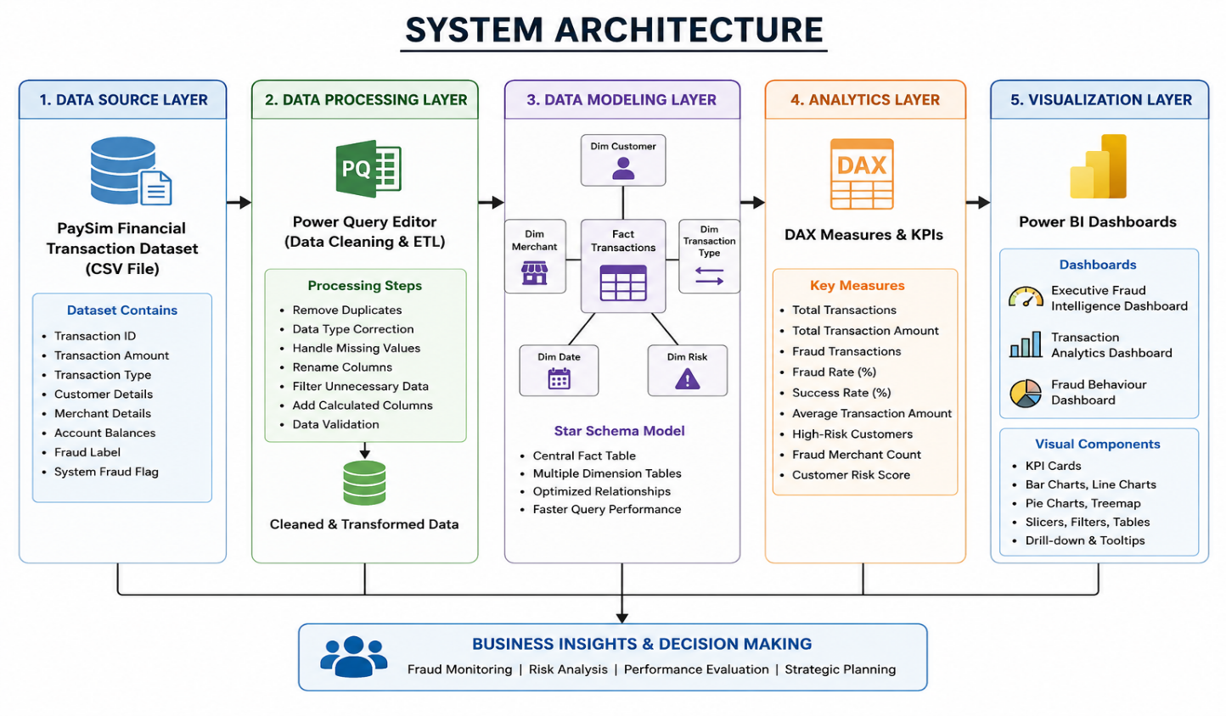
3.3 DATASET DESCRIPTION (PaySim)
The Enterprise Credit Card Fraud Intelligence & Risk Analytics Using Power BI project utilizes the PaySim Financial Transaction Dataset as the primary source of data. PaySim is a synthetic financial dataset that simulates real-world mobile money transactions based on the behavior of an actual financial system. The dataset is widely used in academic research and data analytics projects because it closely resembles genuine banking transactions while maintaining user privacy. It contains over 1 million transaction records, making it suitable for performing large-scale fraud analysis, transaction monitoring, and Business Intelligence reporting. The dataset includes both legitimate and fraudulent transactions, enabling detailed analysis of financial activities and fraud patterns.
The dataset contains several important attributes that describe each financial transaction. These include Transaction Type, Transaction Amount, Customer ID (Sender), Merchant/Receiver ID, Original Balance, Updated Balance, Fraud Label (isFraud), and System Fraud Flag (isFlaggedFraud). Each transaction record provides complete information about the movement of money from one account to another. Different transaction categories such as CASH_IN, CASH_OUT, TRANSFER, PAYMENT, and DEBIT allow comparative analysis of transaction behavior. The fraud label identifies whether a transaction is fraudulent, while the system fraud flag indicates transactions automatically detected by the financial system as suspicious. These attributes form the foundation for analytical calculations and dashboard visualizations.
Before analysis, the dataset underwent extensive data preprocessing using Power Query Editor in Microsoft Power BI. Duplicate records were removed, incorrect data types were corrected, unnecessary columns were eliminated, and missing or inconsistent values were handled appropriately. The cleaned dataset was then transformed into an optimized Star Schema Data Model, which improved analytical performance and reduced report complexity.
Parameter | Description
Dataset Name | PaySim Financial Transaction Dataset
Dataset Type | Financial Transaction Dataset
Source | Kaggle (PaySim Simulation Dataset)
Total Records | 1,048,575 Transactions
Total Columns | 11
File Format | CSV
Domain | Banking & Financial Services
Purpose | Credit Card Fraud Analysis and Business Intelligence Reporting
Tool Used | Microsoft Power BI

3.4 DATA CLEANING AND TRANSFORMATION
Data cleaning and transformation are essential steps in the development of any Data Analytics project because the quality of analytical results depends on the quality of the input data. After importing the PaySim Financial Transaction Dataset into Microsoft Power BI, the dataset was processed using Power Query Editor to remove inconsistencies and prepare it for analysis. During this stage, duplicate records were removed, incorrect data types were corrected, unnecessary columns were eliminated, and missing or invalid values were reviewed. Column names were standardized, and the dataset was formatted to ensure consistency across all tables. These preprocessing activities improved data accuracy and reduced the possibility of errors during dashboard development.
Once the data cleaning process was completed, the dataset underwent data transformation to make it suitable for Business Intelligence analysis. New calculated columns such as Transaction Size, Time Period, and Risk Level were created based on business requirements. Date and time values were transformed into meaningful categories to simplify trend analysis, while transaction amounts were grouped into different ranges for better visualization. The cleaned dataset was then organized into a structured format using a Star Schema Data Model, where the transaction table served as the central fact table and supporting dimension tables contained descriptive information. This transformation improved report performance and enabled efficient filtering across dashboards.
The transformed dataset became the foundation for creating DAX measures, KPIs, and interactive dashboards in Microsoft Power BI. Since the data was properly cleaned and structured, analytical calculations such as Total Transactions, Fraud Transactions, Fraud Rate, Success Rate, Total Transaction Amount, and Average Transaction Amount produced accurate and reliable results. Overall, the data cleaning and transformation process significantly enhanced data quality, optimized report performance, and ensured that the final dashboards provided meaningful insights for fraud monitoring and business decision-making.
To maintain high analytical efficiency, the transformed dataset was thoroughly validated before dashboard development. Relationships between the fact table and dimension tables were verified to ensure accurate filtering and cross-analysis across all visuals. The optimized data model reduced redundancy, improved query execution speed, and enhanced the overall performance of Power BI reports. As a result, the final dataset was well-structured, reliable, and capable of supporting interactive dashboards, dynamic business metrics, and real-time fraud analysis. This comprehensive data preparation process ensured that the insights generated by the system were accurate, consistent, and suitable for effective business decision-making.

3.5 DATA MODELING (STAR SCHEMA)
Data modeling is one of the most important stages in Business Intelligence because it defines how data is organized, connected, and analyzed within the reporting environment. In this project, a Star Schema data model was implemented in Microsoft Power BI to improve analytical performance and simplify report development. The Star Schema consists of a central Fact Transaction table containing transactional data, which is connected to multiple Dimension Tables that store descriptive information such as transaction type, time period, customer details, merchant details, and risk categories. This structure minimizes data redundancy, improves query performance, and enables efficient filtering across reports and dashboards.
The Fact Transaction table serves as the core of the data model and stores all measurable business information, including transaction amount, fraud status, account balances, and transaction identifiers. Surrounding this fact table are several dimension tables that provide descriptive attributes used for slicing and filtering the data. Relationships between the fact and dimension tables were established using primary and foreign keys to ensure accurate data retrieval and maintain referential integrity. This approach allows users to analyze transactions from multiple perspectives, such as transaction type, transaction size, fraud status, and time period.
The Star Schema offers several advantages over a flat data model. Since descriptive information is stored separately from transactional data, the overall model becomes easier to understand, maintain, and extend. It also improves report performance by reducing duplicate information and enabling faster execution of DAX calculations. Interactive features such as slicers, filters, drill-down analysis, and cross-filtering function more efficiently within a Star Schema because Power BI processes relationships more effectively. This results in quicker dashboard response times and a better user experience while working with large datasets.
The implemented data model forms the analytical foundation of the Enterprise Credit Card Fraud Intelligence & Risk Analytics project. All DAX measures, KPIs, charts, and interactive dashboards are built upon this structured model. The Star Schema not only supports efficient reporting but also provides scalability for future enhancements, such as integrating additional datasets, customer information, or predictive analytics models. Therefore, adopting the Star Schema significantly improved the overall efficiency, accuracy, and maintainability of the Business Intelligence solution.

3.6 DAX MEASURES AND KPIs
Data Analysis Expressions (DAX) is the analytical formula language used in Microsoft Power BI to perform advanced calculations and create dynamic business metrics. In the Enterprise Credit Card Fraud Intelligence & Risk Analytics project, DAX measures were developed to calculate important financial indicators and fraud-related statistics. These measures automatically respond to user-selected filters and slicers, allowing real-time analysis without manual calculations. The implementation of DAX significantly enhanced the analytical capabilities of the dashboards by providing accurate and interactive business insights for decision-makers.
Several Key Performance Indicators (KPIs) were created to monitor overall transaction performance and fraud activities. Important KPIs include Total Transactions, Total Transaction Amount, Fraud Transactions, Fraud Rate, Success Rate, Average Transaction Amount, Fraud Merchant Count, High-Risk Customers, and Total Customers. These KPIs provide a summarized overview of financial performance and enable users to quickly evaluate business conditions. KPI cards placed on the dashboards present critical information in an easily understandable format, allowing executives to identify operational issues and fraud trends without analyzing large volumes of raw data.
Measure Name | Purpose
Total Transactions | Calculates the total number of financial transactions.
Total Transaction Amount | Calculates the overall value of all transactions.
Total Customers | Counts the total unique customers.
Total Merchants | Counts the total unique merchants.
Fraud Transactions | Calculates the total number of fraudulent transactions.
Fraud Rate (%) | Calculates the percentage of fraudulent transactions.
Success Rate (%) | Calculates the percentage of successful (non-fraudulent) transactions.
Average Transaction Amount | Calculates the average value of each transaction.
Fraud Merchant Count | Counts merchants involved in fraudulent transactions.
High-Risk Customers | Identifies customers associated with fraudulent activities.
Transaction Volume by Type | Calculates transaction count for each transaction category.
Total Fraud Amount | Calculates the monetary value of fraudulent transactions.

3.7 DASHBOARD DEVELOPMENT
Dashboard development is the final and most important stage of the Enterprise Credit Card Fraud Intelligence & Risk Analytics Using Power BI project. After completing data cleaning, transformation, data modeling, and DAX calculations, interactive dashboards were developed to present financial transaction information in a simple, meaningful, and visually appealing manner. The dashboards were designed following Business Intelligence principles, ensuring that users can quickly understand transaction performance, identify fraud patterns, and make informed decisions. A consistent color theme, interactive filters, KPI cards, and professional visualizations were used throughout the project to improve readability and user experience.
The project consists of three interactive dashboards, each designed to analyze a specific aspect of financial transactions. The Executive Fraud Intelligence Dashboard provides a high-level overview of business performance through KPIs such as Total Transactions, Total Transaction Amount, Fraud Transactions, Fraud Rate, Success Rate, Total Customers, and Total Merchants. It also includes charts showing fraud distribution, transaction trends, and transaction categories, enabling management to monitor overall organizational performance at a glance. This dashboard serves as the primary decision-support interface for business executives.
The Transaction Analytics Dashboard focuses on detailed analysis of transaction activities. It includes visualizations for transaction volume by type, transaction amount analysis, customer distribution, transaction trends across different time periods, and comparative analysis of various transaction categories. Interactive slicers allow users to filter the data based on transaction type, risk level, or other business dimensions, making the dashboard highly flexible for detailed operational analysis. This dashboard helps financial analysts understand transaction behavior and identify operational trends within the organization.
The Fraud Behaviour Dashboard is specifically designed to analyze fraudulent transaction activities. It presents fraud distribution across transaction types, fraud transaction amounts, fraud trends, high-risk customer analysis, merchant-level fraud analysis, and fraud percentage using interactive charts and KPI cards. By combining dynamic DAX measures with interactive visualizations, this dashboard enables users to quickly identify suspicious transaction patterns and evaluate financial risks.
Dashboard Name | Purpose
Dashboard 1 – Executive Fraud Intelligence Dashboard | Provides an executive overview of transaction performance, KPIs, fraud statistics, and business summary.
Dashboard 2 – Transaction Analytics Dashboard | Analyzes transaction trends, transaction types, customer activities, and financial performance.
Dashboard 3 – Fraud Behaviour Dashboard | Monitors fraud patterns, fraud distribution, high-risk customers, merchant analysis, and fraud trends.

CHAPTER 4
PERFORMANCE ANALYSIS

The performance analysis of the Enterprise Credit Card Fraud Intelligence & Risk Analytics Using Power BI project was conducted to evaluate the efficiency, accuracy, and effectiveness of the developed Business Intelligence solution. The analysis primarily focuses on measuring how efficiently the system processes large financial transaction datasets, generates analytical reports, and supports fraud monitoring through interactive dashboards. The project successfully analyzed more than 1 million financial transaction records while maintaining smooth dashboard performance and accurate business calculations. By utilizing optimized data modeling techniques, Power Query transformations, and DAX measures, the system demonstrated excellent analytical capabilities without significant performance issues.
One of the major performance indicators of the project is its report responsiveness. The implementation of the Star Schema Data Model significantly improved query execution and reduced report loading time compared to a flat data structure. Since descriptive information was separated into dimension tables and transactional information was stored within a central fact table, Power BI was able to process relationships efficiently. Interactive slicers, filters, and drill-down features responded quickly to user selections, allowing real-time analysis of transaction data without noticeable delays. This optimization enhanced the overall user experience while handling a very large dataset.
Another important aspect of performance evaluation is the accuracy of analytical calculations. All DAX measures developed during the project were tested under multiple filtering conditions to ensure correct business results. KPIs such as Total Transactions, Total Transaction Amount, Fraud Transactions, Fraud Rate, Success Rate, Average Transaction Amount, Total Customers, and Total Merchants consistently produced accurate outputs based on user-selected filters. The validation process confirmed that the implemented business logic and DAX calculations were reliable and suitable for financial reporting. This accuracy is essential because even small calculation errors could lead to incorrect business decisions in financial environments.
The project also demonstrated excellent dashboard usability and visualization performance. The three dashboards were designed using consistent layouts, professional color combinations, interactive charts, and well-organized KPI cards. Users can easily navigate between dashboards and analyze financial information from different perspectives without requiring technical expertise. Cross-filtering between charts and slicers allows detailed analysis of fraud patterns, customer behavior, transaction categories, and business performance. The visual reports successfully transformed complex financial data into simple and understandable business insights, making the analytical process more efficient for both technical users and management.

4.1 EXECUTIVE FRAUD INTELLIGENCE DASHBOARD ANALYSIS
The Executive Fraud Intelligence Dashboard was developed to provide senior management and decision-makers with a comprehensive overview of the organization's financial transaction performance and fraud statistics. The dashboard presents critical business information through interactive KPI cards, charts, and visualizations, allowing executives to monitor key performance indicators without analyzing raw transaction data. It serves as the primary decision-support dashboard by summarizing the overall health of financial transactions, fraud occurrences, customer activity, and merchant performance. The use of interactive filters enables users to analyze the data from different perspectives while maintaining a simple and user-friendly interface.
The dashboard displays several important Key Performance Indicators (KPIs) that provide an instant overview of business performance. These KPIs include Total Transactions, Total Transaction Amount, Fraud Transactions, Fraud Rate, Success Rate, Total Customers, and Total Merchants. These metrics help management understand the volume of financial transactions processed by the organization and evaluate the effectiveness of fraud prevention mechanisms. The Fraud Rate highlights the percentage of fraudulent transactions compared to the total transaction volume, while the Success Rate indicates the proportion of genuine transactions successfully completed. Together, these KPIs provide a quick assessment of operational efficiency and financial security.
The dashboard also includes multiple visualizations that analyze transaction behavior and fraud distribution. Charts showing transaction type distribution, transaction amount analysis, and fraud transactions by category enable users to identify which transaction types contribute most to fraudulent activities. Trend charts illustrate changes in transaction volume over time, allowing management to monitor business growth and detect unusual fluctuations. Interactive slicers further enhance the dashboard by allowing users to filter the analysis based on transaction type, fraud status, or other business dimensions, making the dashboard flexible and highly informative.
Key Insights Generated from Dashboard 1
- Provides a complete overview of financial transaction performance.
- Displays important KPIs for quick executive decision-making.
- Highlights fraud transactions and overall fraud rate.
- Monitors transaction volume and transaction amount trends.
- Supports interactive filtering for detailed analysis.
- Improves fraud monitoring and operational transparency.
- Enables management to identify business risks and make timely decisions.

4.2 TRANSACTION ANALYTICS DASHBOARD ANALYSIS
The Transaction Analytics Dashboard was developed to provide a detailed analysis of financial transactions and to understand transaction behavior across different categories. While the Executive Dashboard presents an overall business summary, this dashboard focuses specifically on transaction-related insights such as transaction volume, transaction amount, transaction type distribution, customer activity, and operational performance. It enables analysts and management to monitor how transactions are being processed and identify trends that may influence business performance. Through interactive charts, slicers, and dynamic visualizations, users can easily explore transaction data from multiple perspectives without manually examining individual transaction records.
One of the key features of this dashboard is the analysis of transaction categories. The dashboard compares different transaction types such as CASH_IN, CASH_OUT, TRANSFER, PAYMENT, and DEBIT, allowing users to determine which categories contribute the highest transaction volume and transaction value. This analysis helps financial institutions understand customer preferences, transaction behavior, and the operational significance of each transaction type. Visual representations such as clustered column charts, stacked bar charts, and treemaps simplify the comparison of transaction categories and assist management in identifying areas that require greater attention.
The dashboard also provides insights into transaction trends and financial performance by displaying the total transaction amount, average transaction amount, and transaction distribution over different time periods. These visualizations help identify periods of high transaction activity and monitor changes in financial operations. Interactive filters allow users to analyze transactions based on selected categories, risk levels, or other business dimensions, making the dashboard highly flexible for operational analysis. Such information enables organizations to monitor transaction growth, evaluate financial performance, and detect unusual transaction patterns that may indicate potential risks or operational issues.
Key Insights Generated from Dashboard 2
- Analyzes transaction volume across different transaction types.
- Displays the total and average transaction amount.
- Identifies the most frequently used transaction categories.
- Monitors transaction trends and business performance over time.
- Supports interactive filtering using slicers for detailed analysis.
- Helps identify abnormal transaction patterns and operational risks.
- Improves financial reporting and assists management in making informed business decisions.

4.3 FRAUD BEHAVIOUR DASHBOARD ANALYSIS
The Fraud Behaviour Dashboard was developed to provide an in-depth analysis of fraudulent transactions and identify behavioral patterns associated with financial fraud. Unlike the Executive Dashboard and Transaction Analytics Dashboard, this dashboard focuses entirely on fraud-related activities by highlighting fraud distribution, transaction patterns, high-risk customers, merchant involvement, and fraud trends. The primary objective of this dashboard is to help financial institutions monitor suspicious activities, evaluate fraud risks, and support proactive decision-making. Through interactive visualizations and dynamic filtering options, users can quickly identify unusual transaction behavior and investigate potential fraud cases.
The dashboard presents several fraud-related Key Performance Indicators (KPIs), including Fraud Transactions, Fraud Rate, Fraud Merchant Count, Total Fraud Amount, High-Risk Customers, and Success Rate. These KPIs provide a quick summary of the organization's fraud situation and enable management to evaluate the effectiveness of fraud prevention measures. Interactive charts display fraud distribution across different transaction types, allowing analysts to identify which transaction categories are most vulnerable to fraudulent activities. The dashboard also highlights the contribution of individual merchants and customers involved in suspicious transactions, making it easier to detect high-risk entities.
Another important feature of the dashboard is the analysis of fraud trends and behavioral patterns. By examining transaction frequency, fraud occurrence, transaction amounts, and transaction categories, the dashboard helps users recognize abnormal financial activities that differ from normal transaction behavior. Interactive slicers and filters allow analysts to perform detailed investigations by selecting specific transaction types, fraud status, or merchant categories. This flexibility enables organizations to monitor fraud from multiple perspectives and quickly identify emerging fraud trends before they become major financial threats.
Key Insights Generated from Dashboard 3
- Monitors overall fraud activities across the transaction dataset.
- Displays Fraud Rate and Total Fraud Transactions using KPI cards.
- Identifies high-risk customers and fraud-involved merchants.
- Highlights transaction types most affected by fraudulent activities.
- Supports interactive fraud analysis through filters and slicers.
- Detects abnormal transaction patterns and fraud trends.
- Assists management in strengthening fraud prevention and risk management strategies.

4.4 KEY BUSSINESS INSIGHTS
The development of the Enterprise Credit Card Fraud Intelligence & Risk Analytics Using Power BI project generated several valuable business insights that can support financial institutions in improving operational efficiency, reducing fraud risks, and making data-driven decisions. The interactive dashboards transformed more than one million transaction records into meaningful visual information, enabling management to quickly identify transaction trends, fraud behavior, customer activities, and merchant performance. The following are the major business insights obtained from the analysis:
1. Fraud Rate is Very Low but Financially Significant
The analysis revealed that fraudulent transactions represent only a very small percentage of the total transaction volume. Although the fraud rate is low compared to overall transactions, each fraudulent transaction has the potential to cause substantial financial losses. Therefore, continuous fraud monitoring remains essential despite the relatively low fraud percentage.
2. Certain Transaction Types are More Vulnerable to Fraud
The dashboard analysis indicates that fraud is concentrated in specific transaction categories rather than being equally distributed across all transaction types. This suggests that financial institutions should apply stricter security measures and additional verification processes for transaction categories that are more susceptible to fraudulent activities.
3. High Transaction Volume Indicates Strong Business Activity
The organization processes a very large number of financial transactions, demonstrating high operational activity and customer engagement. Efficient transaction processing is essential to maintain service quality while ensuring that fraud detection mechanisms continue to operate effectively without affecting genuine customers.
4. Merchant-Level Monitoring Improves Fraud Detection
Merchant analysis revealed that only a limited number of merchants are associated with fraudulent transactions. Monitoring merchant activities separately enables organizations to identify suspicious merchants early and implement appropriate risk management strategies. Merchant-level analytics can significantly improve fraud investigation and reduce future financial risks.
5. Interactive Dashboards Improve Decision-Making
The use of interactive Power BI dashboards enables executives and analysts to access real-time business information without manually reviewing large datasets. Dynamic KPIs, filters, and visualizations provide immediate access to important business metrics, improving reporting efficiency and enabling faster, data-driven decision-making.
6. Customer Behaviour Analysis Supports Risk Management
Analyzing customer transaction behavior helps identify unusual spending patterns and high-risk customers. Customers whose transaction behavior significantly differs from normal patterns can be monitored more closely, allowing organizations to take preventive actions before fraud occurs.
4.5 BENEFITS OF THE DEVELOPED SYSTEM
The Enterprise Credit Card Fraud Intelligence & Risk Analytics Using Power BI system offers several benefits to financial institutions by transforming large volumes of transaction data into meaningful business intelligence. The developed solution improves fraud monitoring, enhances reporting efficiency, and supports strategic decision-making through interactive dashboards and dynamic analytical reports. By utilizing Microsoft Power BI, Power Query, DAX, and optimized data modeling techniques, the system provides a centralized platform for monitoring financial transactions and identifying fraud-related activities in an efficient and user-friendly manner.
One of the major benefits of the system is its ability to provide real-time business insights through interactive dashboards. Instead of manually analyzing thousands of transaction records, users can monitor key performance indicators such as Total Transactions, Fraud Transactions, Fraud Rate, Success Rate, Total Transaction Amount, and Customer Activity through a single dashboard interface. Dynamic filters and slicers allow decision-makers to explore financial information from multiple perspectives, significantly reducing reporting time and improving operational efficiency.
The system also improves fraud detection and risk management by identifying suspicious transaction patterns, high-risk customers, and fraud-involved merchants. Through visual analysis of transaction categories, fraud distribution, and customer behavior, financial institutions can quickly recognize unusual activities and take preventive measures before financial losses increase. The dashboards provide management with a comprehensive understanding of fraud trends, enabling more effective monitoring and stronger fraud prevention strategies.

Major Benefits of the Developed System
- Provides real-time fraud monitoring through interactive dashboards.
- Reduces manual reporting effort and saves valuable time.
- Improves fraud detection by identifying suspicious transaction patterns.
- Supports faster and more accurate business decision-making.
- Enables detailed analysis of customers, merchants, and transaction types.
- Increases reporting accuracy through automated DAX calculations.
- Optimized Star Schema improves dashboard speed and performance.
- User-friendly interface requires minimal technical expertise.
- Easily scalable for future enhancements and larger datasets.
- Supports future integration with AI, Machine Learning, and predictive fraud detection technologies.

CHAPTYER 5
CONCLUSION AND FUTURE SCOPE

5.1 CONCLUSION
The Enterprise Credit Card Fraud Intelligence & Risk Analytics Using Power BI project successfully demonstrates how Business Intelligence can be applied to analyze large-scale financial transaction data and generate meaningful business insights. By utilizing the PaySim Financial Transaction Dataset, containing more than one million transaction records, the project transformed raw financial data into interactive dashboards that support fraud monitoring, transaction analysis, and executive decision-making. The implementation of Microsoft Power BI enabled the development of a professional reporting solution capable of presenting complex financial information in a simple, organized, and visually appealing manner. The project achieved its primary objective of converting large volumes of transaction data into actionable intelligence that can assist financial organizations in improving operational efficiency and strengthening fraud management.
A systematic development approach was followed throughout the project, beginning with data collection and preprocessing using Power Query Editor. The dataset was cleaned, transformed, and organized using an optimized Star Schema Data Model, which improved report performance and ensured efficient data processing. Dynamic Data Analysis Expressions (DAX) were implemented to calculate important business metrics such as Total Transactions, Total Transaction Amount, Fraud Transactions, Fraud Rate, Success Rate, Average Transaction Amount, High-Risk Customers, and Fraud Merchant Count. These calculations formed the foundation of the analytical dashboards and enabled users to perform real-time analysis through interactive filters and visualizations. The use of Business Intelligence techniques significantly reduced manual reporting efforts while improving the accuracy and reliability of financial analysis.
The project successfully developed three comprehensive dashboards, namely the Executive Fraud Intelligence Dashboard, Transaction Analytics Dashboard, and Fraud Behaviour Dashboard. Each dashboard was designed to analyze financial transactions from a different business perspective while maintaining a consistent user interface and professional design. Together, these dashboards provide valuable insights into transaction patterns, fraud distribution, customer activities, merchant performance, and operational efficiency. The interactive nature of the dashboards enables decision-makers to quickly identify suspicious transactions, monitor business performance, and generate detailed reports without requiring advanced technical knowledge. This demonstrates the practical application of Business Intelligence in supporting financial organizations with faster, data-driven decision-making.
The results obtained from this project clearly indicate that Business Intelligence tools such as Microsoft Power BI can play a significant role in improving fraud monitoring and financial reporting. Although the fraud rate observed within the dataset is relatively low compared to the total number of transactions, the analysis highlights that fraudulent activities remain financially significant and require continuous monitoring.
5.2 FUTURE SCOPES
The Enterprise Credit Card Fraud Intelligence & Risk Analytics Using Power BI project has been developed as a Business Intelligence solution for analyzing financial transactions and monitoring fraudulent activities. Although the current system successfully provides descriptive and diagnostic analytics through interactive dashboards, there are several opportunities for future enhancements. With the continuous advancement of Data Analytics, Artificial Intelligence, and Financial Technologies, the system can be extended to provide more intelligent, automated, and predictive fraud management capabilities. The following are the major future scopes of the project.
One of the most significant future enhancements is the integration of Machine Learning (ML) algorithms for predictive fraud detection. Instead of only analyzing historical transaction data, Machine Learning models such as Random Forest, XGBoost, Decision Trees, or Neural Networks can be trained to predict whether a transaction is likely to be fraudulent before it is completed. This will help financial institutions prevent fraud proactively rather than identifying it after it has occurred.
Another important enhancement is the implementation of Real-Time Fraud Monitoring. Currently, the project analyzes stored transaction data; however, future versions can be connected to live banking databases or streaming platforms using Power BI Service, Azure, or cloud-based technologies. This would enable continuous monitoring of financial transactions and allow organizations to receive instant alerts whenever suspicious activities are detected.
The system can also be expanded by integrating Artificial Intelligence (AI) capabilities. AI-powered anomaly detection, customer behavior analysis, and intelligent recommendation systems can automatically identify unusual transaction patterns and provide risk scores for customers and merchants. This would reduce manual investigation efforts and improve the accuracy of fraud detection while minimizing false positive alerts.
Another future improvement involves integrating additional datasets into the analytical model. Information such as customer demographics, geographic location, merchant profiles, device information, payment channels, transaction history, and credit scores can provide a more comprehensive understanding of financial behavior. Combining multiple data sources would improve analytical depth and support more accurate business decision-making.
The dashboards can also be enhanced by incorporating advanced Business Intelligence features such as forecasting, trend prediction, drill-through reports, AI-powered visuals, and natural language queries available in Microsoft Power BI. These features would enable executives to perform more detailed analysis, predict future business trends, and generate reports more efficiently without requiring advanced technical expertise.

5.3 REFERENCES
The following references were used for understanding Business Intelligence concepts, Microsoft Power BI, Data Analytics methodologies, and financial fraud analysis during the development of the Enterprise Credit Card Fraud Intelligence & Risk Analytics Using Power BI project.
- Microsoft Corporation. Microsoft Power BI Documentation. Available at: https://learn.microsoft.com/power-bi/
- Microsoft Corporation. Power Query Documentation. Available at: https://learn.microsoft.com/power-query/
- Microsoft Corporation. Data Analysis Expressions (DAX) Reference. Available at: https://learn.microsoft.com/dax/
- Kaggle. PaySim Financial Transaction Dataset. Available at: https://www.kaggle.com/datasets/ealaxi/paysim1

5.4 APPENDICES
The appendices section contains additional supporting information related to the development and implementation of the Enterprise Credit Card Fraud Intelligence & Risk Analytics Using Power BI project. These materials provide supplementary details that support the project but are not included in the main chapters to maintain the readability of the report. The appendices include screenshots of the developed dashboards, dataset information, DAX measures, data model, and other supporting materials used during the project implementation.

APPENDIX A
Project Dashboards
This appendix contains screenshots of all three Power BI dashboards developed during the project.
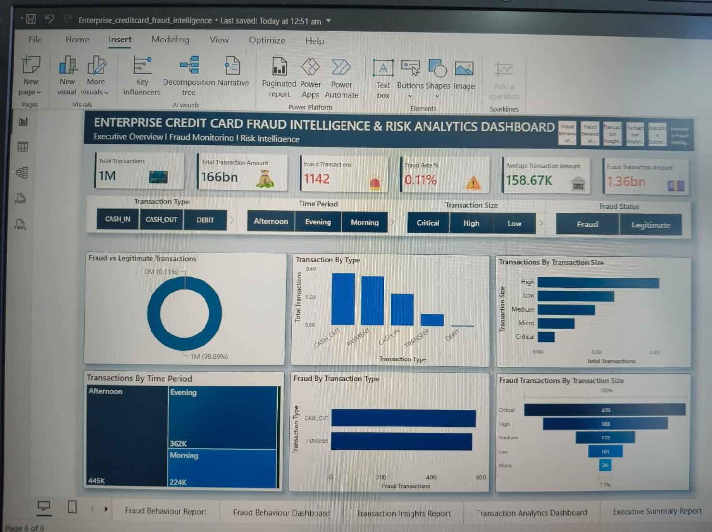
Figure A.1: Executive Fraud Intelligence Dashboard
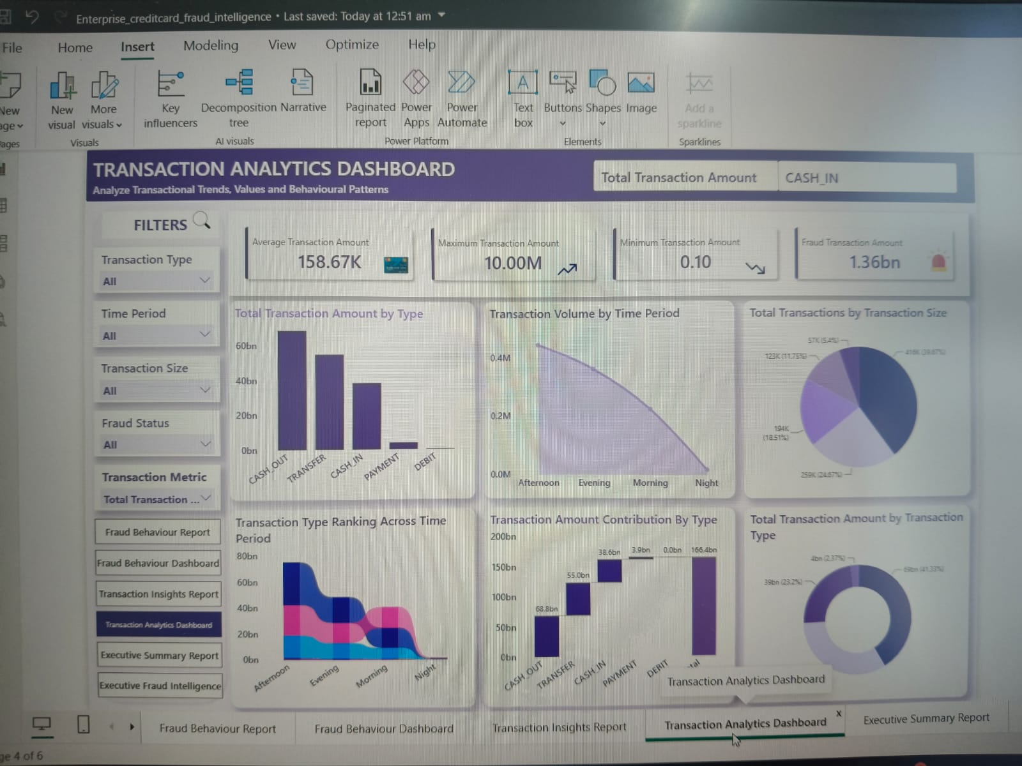
Figure A.2: Transaction Analytics Dashboard
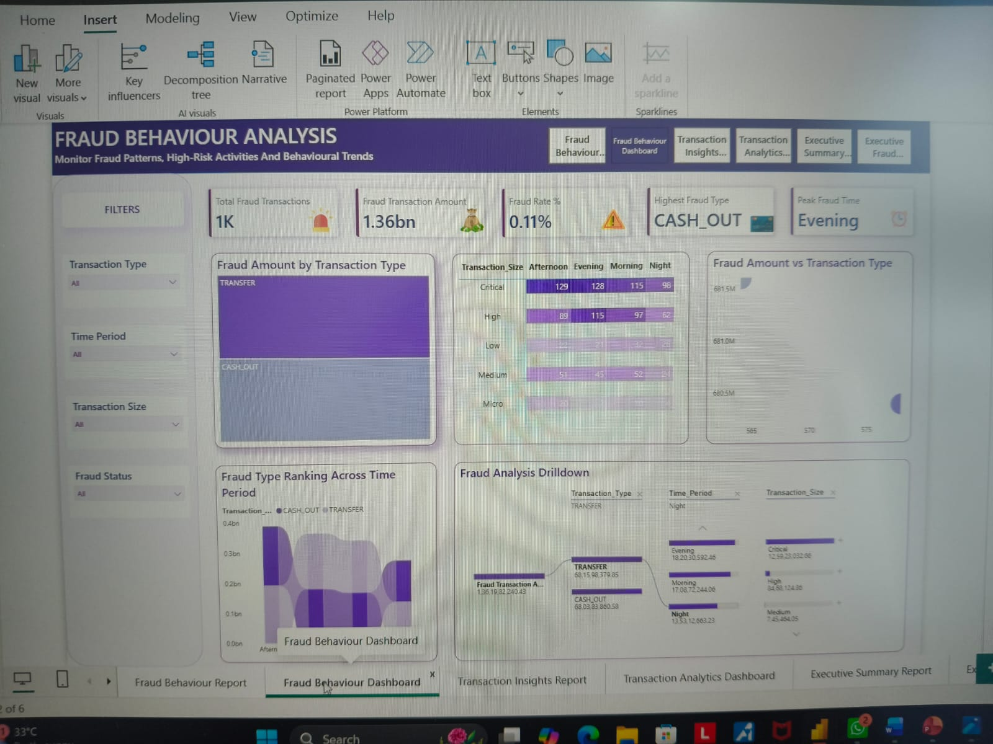
Figure A.3: Fraud Behaviour Dashboard

APPENDIX B
Dataset Information
Dataset Name: PaySim Financial Transaction Dataset
Source: Kaggle
Dataset Type: Financial Transaction Dataset
Total Records: 1,048,575
Total Columns: 11
File Format: CSV
Primary Attributes:
- Transaction Type
- Transaction Amount
- Customer ID
- Merchant ID
- Old Balance
- New Balance
- Fraud Label
- System Fraud Flag
- 